Assignment 3

Research and compare SDLC models suitable for engineering projects. Present findings on Waterfall, Agile, Spiral, and V-Model approaches, emphasizing their advantages, disadvantages, and applicability in different engineering contexts.

# WaterFall Model-

* It is also referred to as a linear-sequential life cycle model. It is very simple to understand and use. In a waterfall model, each phase must be completed before the next phase can begin and there is no overlapping in the phases.

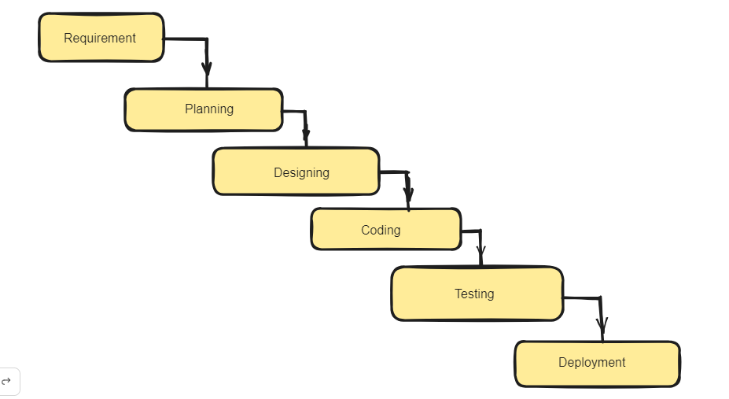

# Advantages-

* Simple and easy to understand and use
* Easy to manage due to the rigidity of the model. Each phase has specific deliverables and a review process.
* Phases are processed and completed one at a time.
* Works well for smaller projects where requirements are very well understood.

# Disadvantages-

* Not a good model for complex and object-oriented projects.
* Poor model for long and ongoing projects.
* Not suitable for the projects where requirements are at a moderate to high risk of changing. So, risk and uncertainty is high with this process model.
* It is difficult to measure progress within stages.

# Agile-

* Agile SDLC model is a combination of iterative and incremental process models with focus on process adaptability and customer satisfaction by rapid delivery of working software product. Agile Methods break the product into small incremental builds. These builds are provided in iterations.

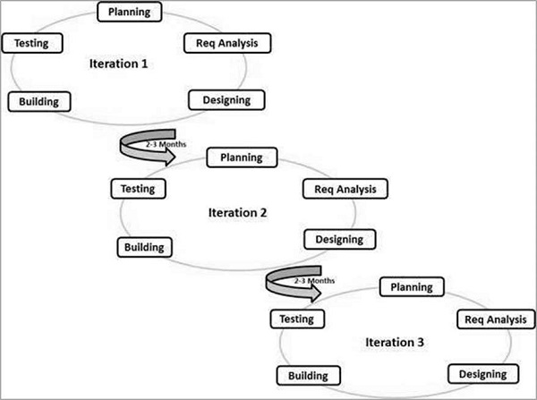

# Advantages-

* Is a very realistic approach to software development.
* Promotes teamwork and cross training.
* Functionality can be developed rapidly and demonstrated.
* Resource requirements are minimum.
* Suitable for fixed or changing requirements
* Delivers early partial working solutions.
* Good model for environments that change steadily.
* Easy to manage.

# DisAdvantages-

* Not suitable for handling complex dependencies.
* More risk of sustainability, maintainability and extensibility.
* An overall plan, an agile leader and agile PM practice is a must without which it will not work.
* Strict delivery management dictates the scope, functionality to be delivered, and adjustments to meet the deadlines.

# Spiral Model

* The spiral model combines the idea of iterative development with the systematic, controlled aspects of the waterfall model. This Spiral model is a combination of iterative development process model and sequential linear development model i.e. the waterfall model with a very high emphasis on risk analysis. It allows incremental releases of the product or incremental refinement through each iteration around the spiral.

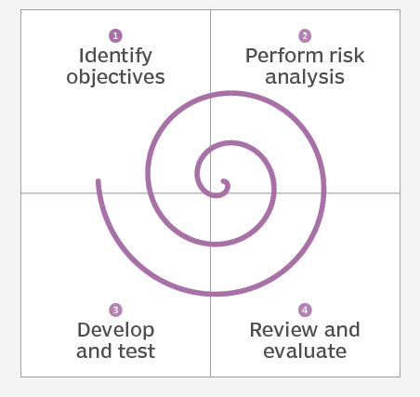

# Advantages-

* Changing requirements can be accommodated.
* Allows extensive use of prototypes.
* Requirements can be captured more accurately.
* Users see the system early.
* Development can be divided into smaller parts and the risky parts can be developed earlier which helps in better risk management.

# DisAdvantages-

* Management is more complex.
* End of the project may not be known early.
* Not suitable for small or low risk projects and could be expensive for small projects.
* Process is complex. Spiral may go on indefinitely.

# V-Model-

* V-Model also referred to as the Verification and Validation Model. In this, each phase of SDLC must complete before the next phase starts. It follows a sequential design process same as the waterfall model. Testing of the device is planned in parallel with a corresponding stage of development.

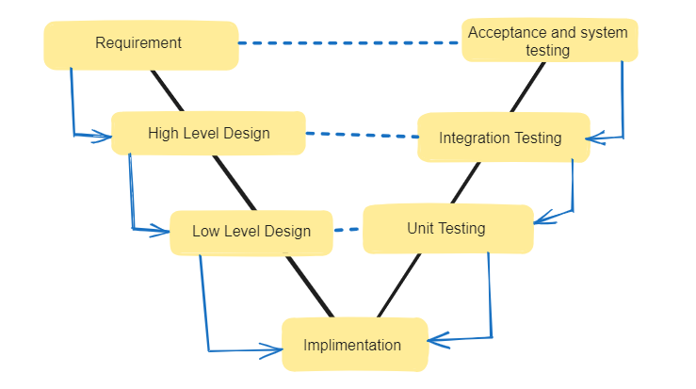

# Advantages-

1. Easy to Understand.
2. Testing Methods like planning, test designing happens well before coding.
3. This saves a lot of time. Hence a higher chance of success over the waterfall model.
4. Avoids the downward flow of the defects.
5. Works well for small plans where requirements are easily understood.

# DisAdvantages-

1. Very rigid and least flexible.
2. Not a good for a complex project.
3. Software is developed during the implementation stage, so no early prototypes of the software are produced.
4. If any changes happen in the midway, then the test documents along with the required documents, has to be updated.